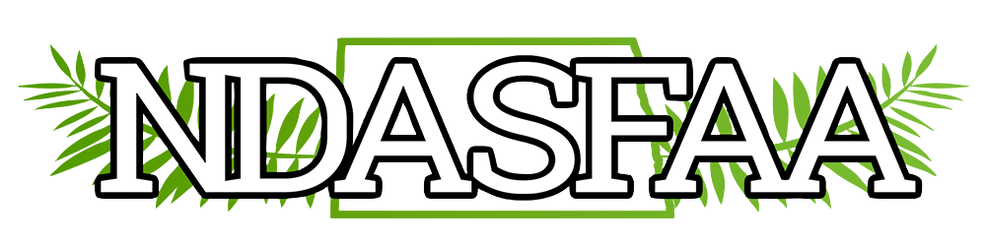

NDASFAA Diversity & Multicultural Initiatives Committee (DMCI)
Annual Report
2021

Members: Melonie Bald Eagle, Tina Ploium, Kathy Lowe, Brenda Zastoupil

The DMCI Committee was engaged in planning the 2020 spring conference philanthropy project, the TEARS organization of Grand Forks. However, due to COVID, the event was cancelled. The 2021 conference committee chairs recommended ND Dollars for Scholars (NDDFS) as the philanthropy project for the 2021! Staci Holzheimer is assisting with tracking the on-line donations. The goal is to issue two $500 scholarships to 1st time ND resident students. NDDFS will accept applications for enrollment beginning fall 2022 at any ND post-secondary institution, including public, private, tribal and proprietary institutions. Students must be enrolled full-time, degree or certificate seeking, and carry a 2.50 minimum grade point average for consideration. Students enrolling at institutions across the state already benefit from this program and the committee encourages the membership to consider supporting this year’s project!

The committee has lost several members this past year. If someone from the membership has interest in topics on diversity and multicultural issues, please consider joining the DMCI Committee.

