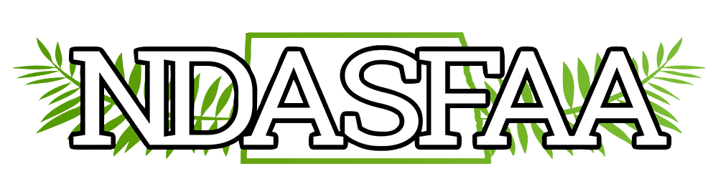
Electronic Initiatives Committee Meeting Agenda
April 14th, 2021

- Introduction of Members and what EI Committee does.
  - Members present:
    - Becky Nielsen Lynnes Welding Training Co-Chair
    - Crystal Tangsrud NDUS Co-Chair
    - Scott Lingen BSC Member
    - Desiree Cannon Williston State Member
    - Katie Simonson UND Member
    - Sherry Bisek NDUS Member
- Old Business from 2019’s Conference regarding Archiving. Discuss how to explain how things can be stored on the website but not be visible to the public, and how to share that with the members.
  - Motion to Amend NDASFAA Bylaws on Archiving (Electronic Initiatives Committee) – At 2019 conference, discussed archiving website. The Electronic Initiatives Committee is researching options and will bring to next meeting. Everything was brought over from last website and space/storage is not an issue. The committee will bring a motion forward to next business meeting. Judy sent all old minutes to Becky, and Becky and Crystal archived them. No more paper files.
  - EI Committee discussed the archiving concern. EI suggestion is to put a message on the archiving page that archived documents are available at request. These documents will be held in the files section on the backend of the website. Maybe EI can send out a survey to see how many want the files on the front facing website.
  - Archiving after 5 years
- Update on any changes with website
- Updates that have been done
- Looking forward at items on the list for the next year
  - EI will organize the file section on the website, so if someone were to need access it would be “user friendly.”
  - Update Timeline
    - Add in once-a-year email to listserv to update membership info

