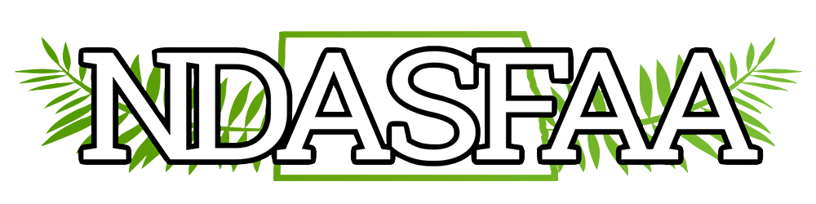
NDASFAA Executive Board Meeting
Wednesday, April 14, 2021
9:00 am CST
Microsoft Teams Meeting

Welcome/ Call to Order - President Marcia Pritchert called the meeting to order at 9:00 am CDT.

Present – Board Members: Marcia Pritchert, Judy Hager, Christopher Meek, Amanda Woidyla, Bethany Vincent, Chelsea Larson; Guests, Andrea Carver

Additions to the Agenda – None brought forward

Approval of Agenda – Chris moved to approve, Bethany seconded, agenda approved

Approval of Minutes from March – Judy moved to approve, Bethany seconded, minutes approved

Treasurer’s Report – Bethany Vincent
Bethany will discuss details at Annual Business meeting. Twenty-seven members have registered for conference, and 22 have paid. Expenses have not yet been calculated, but we are only expecting gavel and retirement gifts to be filed. Minimal expenses due to virtual conference. All institutions have renewed, 8 associations have renewed, and three new associations have applied. Credible and Discover Student Loans have also paid, and Earnest has completed application but not yet paid; therefore, they are not added to website yet. HSCW was virtual with no expenses. BND donated breakfast money to scholarship fund and awarded for academic year 21-22. Seven scholarships will be awarded based on $2000 donated from BND plus $100 donation from NDASFAA. All ND State filings are current.

Judy moved to approve Treasurer’s report, Chris seconded, Treasurer’s Report approved.

New Business:

RMASFAA Update – Marcia Pritchert
Marcia reported that Summer Institute registration is open, and the event will be held in Kearney, Nebraska. Price has been reduced, and savings passed to membership. Looking at potential virtual option at a different time. RMASFAA conference hosted jointly by Nebraska and Wyoming with plans to offer it both virtual and in-person. Audio-visual costs will be higher, and they have hired a vendor to assist with this. RMASFAA requested state delegates to give some insight on what membership institutions are planning. There are scholarship opportunities for both Summer Institute and annual conference. Officer nominations are open and on website. Encourage members to volunteer. Leadership pipeline application is open. Marcia asked a question that was posed to RMASFAA: How does your state association determine how much insurance to carry? NDASFAA does not carry insurance. Discussion around what we would insure since we do not have a lot of assets and our organization is relatively small. Amanda indicated that Dollars for Scholars has insurance due to being a 501(c)3 organization but that it might be related to Scholarship America organizations. Bethany will reach out to smaller groups like Wyoming and South Dakota to see how they handle and report back to the board.

Election Results – Chris Meek
There were no write-ins. Fifteen of 21 institutions voted. Bethany and Sheila were elected. Congratulations! Associates could not vote since there was not an Associate Member at Large on the ballot. Chris will announce at committee update at the conference. He will also request a motion to destroy electronic ballots and voting records at Business Meeting.

Fall Professional Development – Marcia Pritchert
Discussion around what has been offered in the past, wishes expressed by members, and how COVID has potentially changed what is offered. It is generally two half-days, normally held in Bismarck, and usually involves discussion on new, trending topics and opportunities for networking. There has not been one held since 2017 due to turnover of staff. Members have been surveyed in recent years. There seems to be more interest in shorter sessions than a longer credentialing session. FSA Partner Connect has made training easier to access. NDASFAA will push reminders of these opportunities to members. Judy noted that if you teach at Summer Institute, you can take as many NASFAA credential exams for free as you want. Marcia will add the discussion of a Fall professional development event to Business Meeting to gauge interest on an in-person offering.

Strategic Long-Range Plan (SLRP) – Judy Hager
Judy is attending Leadership Symposium as part of requirement of President-Elect of NDASFAA. They are encouraging state associations to create SLRP’s. Brenda Hicks of RMASFAA reached out to Judy to partner on this and shared the Kansas plan. The first step would be development of a Mission or Vision statement. Judy is working to develop one for her office. Discussion of members that it is a good idea to help the organization focus, make decisions, and determine opportunities to improve. We need to request input from members, request volunteers, and create a committee. We can borrow from other associations’ plans. Marcia will discuss with the Professional Development committee and provide an update at the Business Meeting to ask for people who are interested or who may have experience with this.

SNAP Benefits – Marcia Pritchert
Brought to NDASFAA by Brenda Zastoupil. Wahpeton and Minot had indicated that they had talked to their local offices, and the offices were not aware of the new eligibility changes. Marcia will ask Awareness committee to push this out as well. Marcia and Bethany will discuss with Awareness committee and inquire about the state contacting the ND Department of Human Services to educate on the changes and see what documentation they would require from students.

Updates to Website (Member Achievements page) – Marcia Pritchert
Wall of Honor for retirees. They need to be nominated. 156 years of experience with six retirees. Marcia indicated that all six plan to attend the conference social.

Unfinished Business:

2022 Conference – Andrea Carver
Arc at WSC is available for dates: 4/6-4/8 and will cost $200 per day, which includes A/V and kitchen access. Hotel El Rancho in Williston has a special rate and would hold a block for $45/night. The brewery is connected, and is the best restaurant in town. WSC can cater to Arc. Bethany inquired about the requirement of a deposit and the cancellation policy. Andrea will request more information. Andrea is concerned about staffing and resources. Chelsea indicated that UND can assist with schedule, logo, agenda, speakers. Conference committee can also assist. WSC will handle on-site logistics. Marcia will add our dates to the RMASFAA calendar. UND will reach out to WSC to get started on planning. Andrea indicated that WSC is excited to have the opportunity to host, and she has buy-in from other units as well.

Discussion on Conference Rotation Schedule
Discussion around revision of rotation schedule so that smaller institutions with limited resources are less impacted. Board recommends limiting to a rotation of: Fargo, Minot, Grand Forks, Bismarck plus a members’ choice location. Encourage conference committee to help with programming for all locations, so that it does not always land on the local institution to handle everything. Board will bring recommendation to the Business Meeting to edit the P&P and request a vote.

Proposed Rotation: Bismarck, Fargo, Members’ Choice, Minot, Grand Forks.

Reminder that Member’s Choice can be any location, not an institution, necessarily.

Proposal would mean 2023 conference in Bismarck.

Meeting adjourned at 10:09 am CDT

Minutes submitted by Chelsea Larson, Secretary

