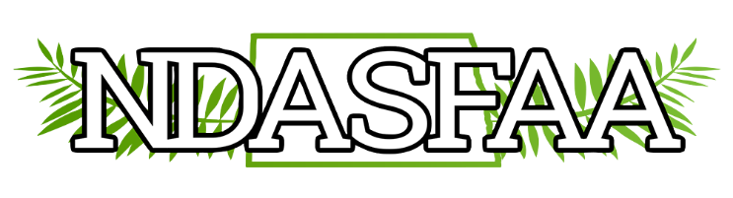
Business Meeting Agenda
Thursday, March 30, 2023

Welcome – Passing of the gavel from Outgoing President Sheila Dolan to Incoming President Matthew Sanchez

Call to Order – President Sanchez

Approval of the Agenda

Roll Call

Approval of the Minutes from April 7, 2022

Treasurer’s Report – Bethany Vincent

Committee Reports
- Nominations: Judy Hager, Chair

President Elect: Andrea Carver , Williston State College
Kelsey Walters, Lake Region State College
Scott Skaro, United Tribes Technical College

Treasurer: Bethany Vincent, North Dakota State University

- Conference 2023: Karrie Huber, Judy Hager, Matt Sanchez,Amanda Woidyla
- Awareness: Tammie Reger & Rachel LaForce, Co-Chairs
- Awards & Membership: Kristen Kihle & Amanda Woidyla, Co-Chairs
- Electronic Initiatives: Crystal Tangsrud & Sherry Bisek, Co-Chairs
- Diversity, Equity, & Inclusion, Brenda Zastoupil, Chair
- Professional Development: Marcia Pritchert & Judy Hager, co-chairs

Old Business
- State Swap: North Dakota will be represented at the UTAH spring conference by Scott Lingen, BSC. Christopher Simpson is our guest from Bellevue University, NE

New Business
- Open committee chairs: Diversity, Equity & Inclusion, Other?
- North Dakota to host RMASFAA October 2026
  - Site Proposal needed by October 2023
  - Committee Chair(s) needed by Spring 2024
  - Venue contract singed by October 2024

Annoncements: RMASFAA Summer Institute, June 4-8, 2023 Wichita State University, Wichita, KS
RMASFAA Leadership Pipeline, Applicants and Mentors needed

