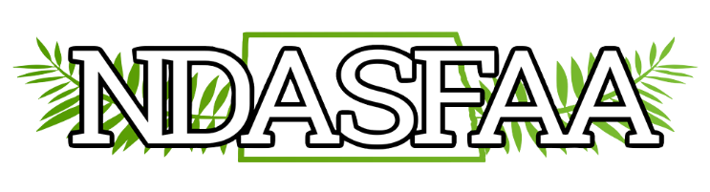
Electronics Initiatives Committee
2023 Annual Report

- EI Committee continues to work with all NDASFAA Committees to provide them their website needs. This includes the HS Counselor Workshop, Directory updates, and Spring Conference.
- During our spring meeting we discussed and updated our Committee Responsibilities and Timeline, along with the Association Website section of the NDASFAA P&P. This brings these items more in line with what the committee has been doing over the last several years. These are now approved by the NDASFAA Board.
- Going into the next year, our committee hopes to focus on training other committee members on tasks to allow them to be spread out amongst members. This includes the creation of a new NDASFAA-Web list-serv so that all future website requests can be shared across the committee. We’ve also assigned an EI delegate to each of the committees who, after training, will be primarily responsible for their updates/needs.
- As usual we will be sending out our annual request for Directory updates following the conference.

