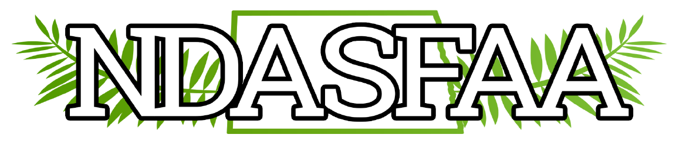

2024 NDASFAA DEI Annual Report
Members: Julie Flakker, Michelle Marks, Kristie Myers (chair), Melonie Bald Eagle (vice chair), Brenda Zastoupil, Becca Larsen and Lindsey One Bear, all present; Scott Skaro, Jacquelyn Zeltinger and Jazalyn Corley, unable to attend.
Notified Electronic Initiatives Committee to remove 2 members who are no longer on the committee for 2024: Kathy Lowe (about to retire) and Kirsten Pratt (no longer in financial aid)

Discussion:
The DEI Committee was engaged in the 2023 conference through the philanthropy project. $1,450 was raised for Heaven’s Helpers Soup Café’ in Bismarck. The organization selected for 2024 is Matthew’s Voice Project, a nonprofit that works with homeless liaisons in each school district to provide students who are unaccompanied, homeless and at-risk youth with basic necessities that will allow them to stay in school and ultimately graduate. We hope to have another successful partnership this year. Update: Our association generously donated $1,455 along with 2 gift cards and 3 hoodies to Matthew’s Voice Project. The DEI Committee thanks everyone for their kindness and generosity!
The committee compiled a list of resources that will be helpful for culturally diverse students who are nearing their high school graduation. This list will be shared with the chair of the Awareness Committee to share with high school guidance counselors as part of the High School Counselor’s Workshop in the fall.
A call for new members was given for 2024-25; if interested, notify Kristie or Melonie. There was no interest expressed by anyone else in chairing the committee for the 2025 spring conference e in Minot so Kristie agreed to do another year.

