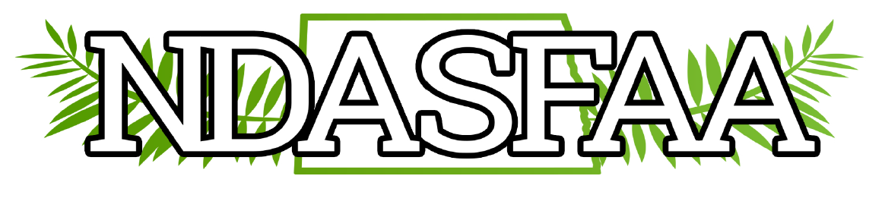

2025 NDASFAA DEI Annual Report
Members: (10) Kristie Myers (co-chair), Melonie Bald Eagle (co-chair), Brenda Zastoupil, Becca Larsen, Lindsey One Bear, Scott Skaro, Jacquelyn Zeltinger, Brigit Eagle, Martiza Urlaub, Bethany Vincent.
Notified Electronic Initiatives Committee to remove one member Jazalyn Corley and add three new members Brigit Eagle, Maritza Urlaub, and Bethany Vincent.
Philanthropy Project:
The DEI Committee was engaged in the 2024 conference through the philanthropy project. $1,455 was raised for the Matthews Voice Project in Fargo. The organization selected for 2025 is Minot Public Schools Foundation (MPSF) Classroom Innovation Grant, a nonprofit that works with teachers in the Minot school district to provide grants to support creative classroom projects that are generally not funded by state or federal funding. We hope to have another successful partnership this year. *Update the committee raised $1,100.02 for the MPSF Classroom Innovation Grant.
Diversity Resources
The committee compiled a list of resources, and other items of interest, related to diversity that is available to the NDASFAA membership. This list will be shared with the chair of the Awareness Committee.
Land Acknowledgement
The Conference Committee proposed opening this year’s conference by reading a land acknowledgement. This is a formal statement that acknowledges the original people of the land, what they’ve experienced historically, what they’re contributing to our region now, and what we’d do as an organization to support them. Since NDASFAA doesn’t have our own land acknowledgement, Lindsey Benson will read Minot State University’s.
2026 Goals
- Use Facebook page in addition to the NDASFAA listserv email to share relevant news or articles. Note: Resources are not listed on the website because there’s nobody assigned to check or update them regularly.
- Establish our own land acknowledgement for NDASFAA as opposed to using the one for the school that hosts the conference each year. This is a project that requires collaboration from many people such as Tribal College presidents, Indigenous staff, faculty and student groups, Native American Commissions, and elders in the community. Creation of a land acknowledgment is a lengthy process that could take a significant amount of time. Crystal T. shared with the group that there is a session about land acknowledgements at the upcoming NASFAA conference this year. She will plan to go and share her learnings with our committee.
Committee Leadership
- Lindsey One Bear will co-chair the DEI committee along with Melonie Bald Eagle for the upcoming year.

