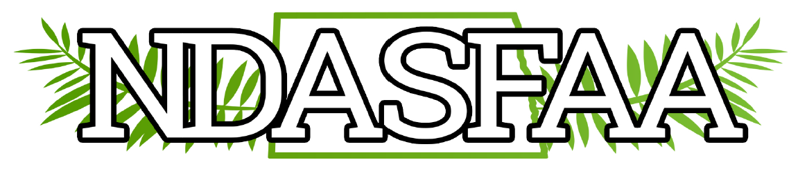

2025 NDASFAA DEI PRE-CONFERENCE COMMITTEE MEETING
April 3, 2025 – 2:30 p.m.
Call to order: 2:30, Melonie Bald Eagle (co-chair)
Members present: Melonie Bald Eagle (co-chair), Kristie Myers (co-chair), Brenda Zastoupil, Rebecca Larsen and Lindsey One Bear. Crystal Tangsrud from the Conference and EI Committees also sat in. Three new members joined the meeting – Maritza Urlaub, Destiny Aranda and Bethany Vincent, all from NDSU. Members not present: Scott Skaro, Jacquelyn Zeltinger and Bridget Eagle.
Kristie informed Crystal that Bridget Eagle has replaced Jazzlyn Corley at Sitting Bull College, and Bridget confirmed that she’d like to serve on this committee. Crystal also updated the committee list on the NDASFAA website to include our new members.
Discussion:
- The 2025 Philanthropy Project
  - Our partnership with Minot Public Schools Foundation Classroom Innovation Grant is open and accepting monetary donations online. Crystal T. offered to put something about the philanthropy project on the NDASFAA Facebook page, as some retirees may be interested in donating.
  - Melonie, Bethany, Brenda and Lindsey all plan to attend the conference and are willing to help staff the philanthropy table. Melonie will purchase a lockbox so the money collected will be secure.
  - Kristie notified Lindsey Benson that a table is needed for our committee to set up camp. Decorations and candy for the table will be minimal and provided by the entertainment and decorations committee.
  - A representative from MPSF will briefly introduce the Classroom Innovation Project organization on day one of the conference and accept the final donation on day three. MPSF has a giant cardboard check that we can use when presenting the final gift.
  - Discussed slide deck options that will play during breaks. Melonie is working on a flyer with a QR code for this.
  - Melonie has been compiling a list of resources to be shared with the High School Counselor’s through the Awareness Committee at the HSC Workshop this fall. If you come across any helpful articles, please share them with Melonie.
- Land Acknowledgement
  - The Conference Committee proposed opening this year’s conference by reading a land acknowledgement. This is a formal statement that acknowledges the original people of the land, what they’ve been through, what they’re contributing now, and what we’d do as an organization to support them.
  - Since NDASFAA doesn’t have our own land acknowledgement, Lindsey Benson will read Minot State University’s.
- 2026 Goals:
  - Use Facebook page in addition to the NDASFAA listserv email to share relevant news or articles. Note: Resources are not listed on the website because there’s nobody assigned to check or update them regularly.
  - Establish our own land acknowledgement for NDASFAA as opposed to using the one for the school that hosts the conference each year. This is a project that requires collaboration from many people such as Tribal College presidents, Indigenous staff or faculty groups, the Native American Commission, and elders in the community. If done right, it’s a lengthy process that could take a significant amount of time. Next year’s conference is at CTS in Grand Forks. They don’t have a land acknowledgement but can probably read UND’s. Crystal T. stated there is a session about land acknowledgements at the NASFAA conference this year. She will plan to go and share her learnings with our committee.
- Committee Leadership
  - The DEI Committee is looking for someone to chair the committee for 2026. Lindsey OneBear is willing to co-chair but a volunteer is needed for her counter-part. If anyone is interested, please notify Melonie Bald Eagle.

Adjourn 3:47 p.m.

