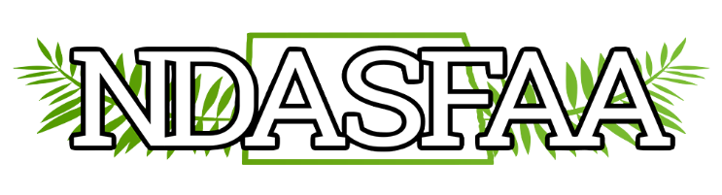
2025 Awareness Committee Report

Members: Rachel Grossman, Alexandria Bauer, Lindsey Benson, Tonya Critz, Sheila Dolan, Karrie Huber, Laurie Kovar, Chris Meek,
Bethany Vincent, Kelsey Walters, Laurie Weber

The goal of the Awareness Committee is to promote student success using financial literacy as a tool to bridge the gap between students and post-secondary education. We do this by:
- Encouraging students to attend financial aid nights/workshops offered to them by awarding yearly scholarships to students who attend.
- Hosting counselor workshops for high school counselors and other associated professionals to provide updates on a wide variety of educational topics such as federal information and guidelines from Department of Education, FAFSA related information, North Dakota State Grant and Scholarship program information, etc.
- Creating and promoting awareness about the FAFSA, how to complete it, and the benefits associated with completing it.
- Sharing information related to available resources and/or contacts located in local financial aid offices to create and promote financial literacy within the local region and within the state.

High School Counselor Workshops

2024 counselor workshops were hosted both in-person and virtually this year. DSU, MSU and UND hosted workshops in-person. NDSU & UMary worked together to host a virtual workshop. LRSC took a year hiatus and plans to host again fall 2025. BND donated $1200 to cover workshops expenses-breakfast, materials, etc. The remaining $302.28 was left in the NDASFAA account to be used for professional development. There was a total of 114 individuals registered for the workshops.

Date | Location | Registrations
10/30/2024 | MSU | 26
11/13/2024 | UND | 22
11/26/2024 | DSU | 11
12/10/2024 | Virtual | 55
 |  | 114

Financial Aid Sessions

NDASFAA members participated in 24 financial aid events with approximately 440 students attending. Events included financial aid presentations at high schools, FAFSA application events and financial aid tabling events.

